**Durak User Guide**

Connor Simmonds-parke, Emeka Okoisama, David Osagiede, Alexander Nelson

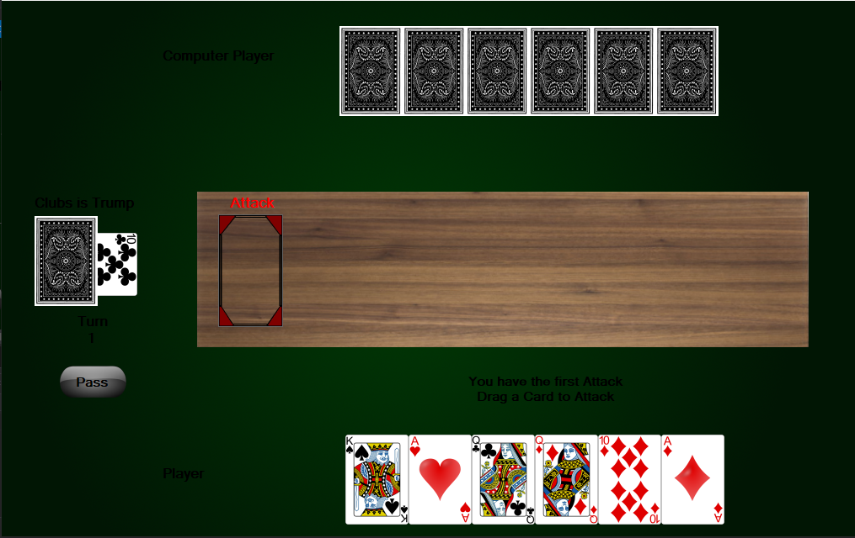

***About***

Durak is a popular Russian card game with the objective to get rid of all the cards in your hand while there are no more cards left in the pick-up deck (‘Talon’). The last player left with cards is the loser, and coined the fool (‘Durak’).

***Setup***

While the game can support up to six players, this is a **one on one**version that supports a deck of either **20** (Ten to Ace in each Suit), **36** (Six to Ace in each Suit), or **52** (standard deck).

The deck is shuffled and both players will receive six cards to start, face down, one at a time. Then another card is drawn and placed face up, diagonally, under the pick-up deck (it will be the last card drawn) and determines the trump suit (Spade, Diamonds, Heart, Clubs). The trump suit means that any card of that same suit will beat even the highest card of any other suit.

The player with the **lowest trump suit** will be the *attacker* first. If no player has a **trump** card, then the player with the lowest rank card will attack first. If both players have the same lowest rank and no **trump**, then the game will randomly choose who is *attacker* first.

***Gameplay***

This version of the game is played in **turns**. Each turn consists of an *attacker* and *defender*.

***Attack***

The *attacker* starts the turn by playing a card face-up on the table. If the *defender* is able to defend against the first attack card, then the *attacker* can make another attack under the conditions that:

* The *defender* is not out of cards
* There has not been six attacks already made
* The next attack must be a card with the same rank as any card previously played this **turn**

If the *defender* cannot defend against the attack, or chooses to pass, then the *attacker* has won the **turn**.

***Defense***

The *defender* can choose to either defend or pass and give up the turn. To defend, the *defender* must play a higher rank card of the same suit as the *attacker’s* card, or play any card of the **trump** suit (if the *attacker* played a card with the **trump** suit, then the *defender* must beat the rank). The card is played overlapping the attacking card so that both are visible.

The *defender* wins the **turn** under the conditions that:

* They have defended against six attacks
* The *attacker* can no longer play any attack cards
* The *defender* has no more cards in their hand

If the *attacker* wins the turn, then the *defender* must pick up all the cards on the table, and the attacker gets to start the next turn as the *attacker* once again.

If the *defender* wins the turn, then all the cards on the table are moved to a discard pile, and the *defender* gets to start the next turn as the *attacker*.

In either case, any player with less than six cards in their **hand** must draw from the pick-up deck until they have six cards, starting with the *attacker*.

When there are no more cards in the pick-up deck, the first player to hold zero cards in their **hand** is the **winner**.

***Citations***

1. <https://www.pagat.com/beating/podkidnoy_durak.html>
2. <http://gambiter.com/cards/Durak.html>
3. https://en.wikipedia.org/wiki/Durak

***User Interface***

1. Computer’s Hand 5. The Current Attack/Defend Turn
2. Deck of Cards. 6. Pass/Pick Up (Ends Round)
3. The Trump Card/Suit 7. Your Hand

4. The River

